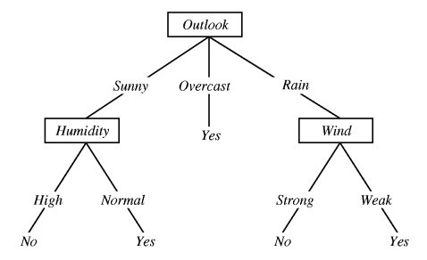
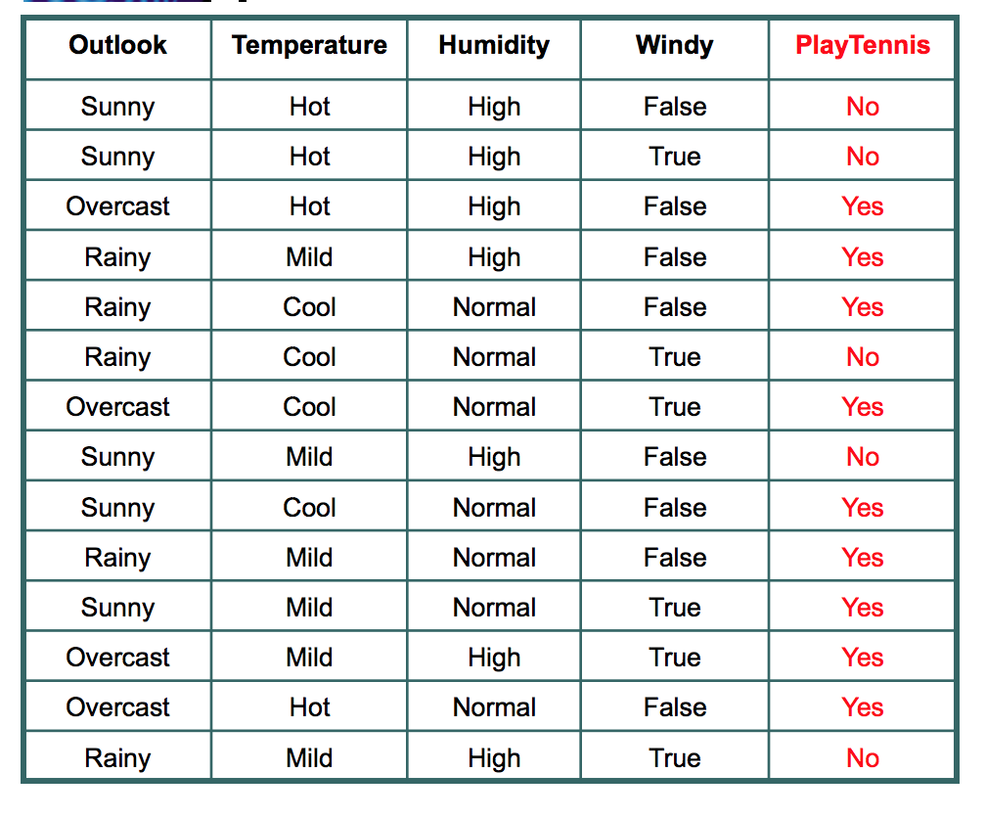
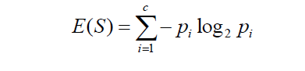
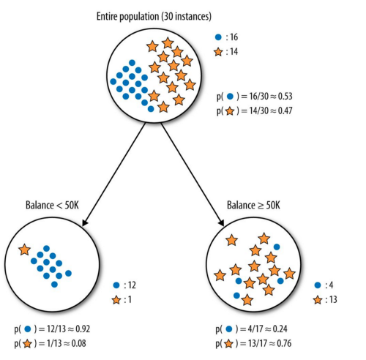
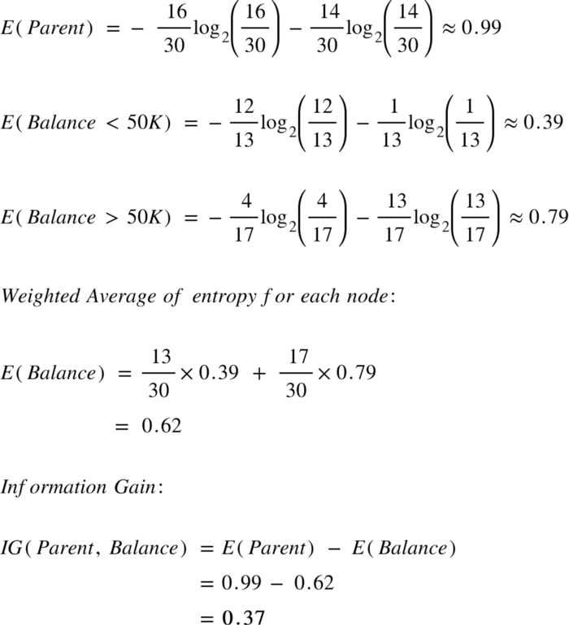
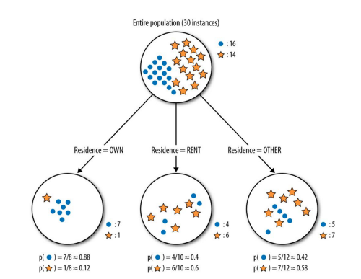
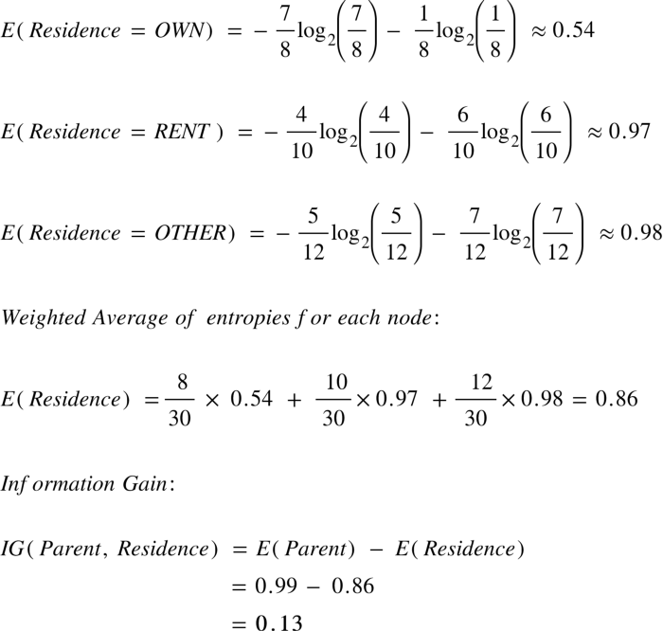
Introduction
Decision Tree learning is used to approximate discrete valued target functions, in which the learned function is approximated by Decision Tree. To imagine, think of decision tree as if or else rules where each if-else condition leads to certain answer at the end. You might have seen many online games which asks several question and lead to something that you would have thought at the end. A classic famous example where decision tree is used is known as Play Tennis.
If the outlook is sunny and humidity is normal, then yes, you may play tennis.

Where should you use decision tree?
At any scenario where learning data has following traits:
- The learning data has attribute value pair like in the example shown above: Wind as an attribute has two possible values – strong or weak
- Target function has discreet output. Here, the target function is – should you play tennis? And the output to this discreet output – Yes and No
- The training data might be missing or have error

Dataset for Play Tennis

Entropy
Entropy is a measure of randomness. In other words, its a measure of unpredictability. We will take a moment here to give entropy in case of binary event(like the coin toss, where output can be either of the two events, head or tail) a mathematical face:
Entropy = -(probability(a) * log2(probability(a))) – (probability(b) * log2(probability(b)))
where probability(a) is probability of getting head and probability(b) is probability of getting tail.
Of course this formulae can be generalised for n discreet outcome as follow:
Entropy = -p(1)*log2(p(1)) -p(2)*log2(p(2))-p(3)*log2(p(3))………………………..p(n)*log(2p(n))
Entropy is an important concept. You can find more descriptive explanation here.

Information Gain
In the decision tree shown here:
We decided to break the first decision on the basis of outlook. We could have our first decision based on humidity or wind but we chose outlook. Why?
Because making our decision on the basis of outlook reduced our randomness in the outcome(which is whether to play or not), more than what it would have been reduced in case of humidity or wind.
Let’s understand with the example here. Please refer to the play tennis dataset that is pasted above.
We have data for 14 days. We have only two outcomes :
Either we played tennis or we didn’t play.
In the given 14 days, we played tennis on 9 occasions and we did not play on 5 occasions.
Probability of playing tennis:
Number of favourable events : 9
Number of total events : 14
Probability = (Number of favourable events) / (Number of total events)
= 9/14
= 0.642
Now, we will see probability of not playing tennis.
Probability of not playing tennis:
Number of favourable events : 5
Number of total events : 14
Probability = (Number of favourable events) / (Number of total events)
=5/14
=0.357
And now entropy of outcome,
Entropy at source= -(probability(a) * log2(probability(a))) – (probability(b) * log2(probability(b)))
= -(Probability of playing tennis) * log2(Probability of playing tennis) – (Probability of not playing tennis) * log2(Probability of not playing tennis)
= -0.652 * log2(0.652) – 0.357*log2(0.357)
=0.940
So, entropy of whole system before we make our firest question is 0.940
Now, we have four features to make decision and they are:
- Outlook
- Temperature
- Windy
- Humidity
Let’s see what happens to entropy when we make our first decision on the basis of Outlook.

Outlook
If we make a decison tree divison at this level 0 based on outlook, we have three branches possible; either it will be Sunny or Overcast or it will be Raining.
- Sunny : In the given data, 5 days were sunny. Among those 5 days, tennis was played on 2 days and tenis was not played on 3 days. What is the entropy here?
Probablity of playing tennis = 2/5 = 0.4
Probablity of not playing tennis = 3/5 = 0.6
Entropy when sunny = -0.4 * log2(0.4) – 0.6 * log2(0.6)
= 0.97
2. Overcast: In the given data, 4 days were overcast and tennis was played on all the four days. Let
Probablity of playing tennis = 4/4 = 1
Probablity of not playing tennis = 0/4 = 0
Entropy when overcast = 0.0
3. Rain: In the given data, 5 days were rainy. Among those 5 days, tennis was played on 3 days and tenis was not played on 2 days. What is the entropy here?
Probablity of not playing tennis = 2/5 = 0.4
Probablity of playing tennis = 3/5 = 0.6
Entropy when rainy = -0.4 * log2(0.4) – 0.6 * log2(0.6)
= 0.97
Entropy among the three branches:
Entropy among three branches = ((number of sunny days)/(total days) * (entropy when sunny)) + ((number of overcast days)/(total days) * (entropy when overcast)) + ((number of rainy days)/(total days) * (entropy when rainy))
= ((5/14) * 0.97) + ((4/14) * 0) + ((5/14) * 0.97)
= 0.69
What is the reduction is randomness due to choosing outlook as a decsion maker?
Reduction in randomness = entropy source – entropy of branches
= 0.940 – 0.69
= 0.246
This reduction in randomness is called Information Gain. Similar calculation can be done for other features.

Temperature
Information Gain = 0.029

Windy
Information Gain = 0.048

Humidity
Information Gain = 0.152
We can see that decrease in randomness, or information gain is most for Outlook. So, we choose first decision maker as Outlook.

Flow of Decision Tree Algorithm

Information Gain
- Information gain is the measurement of changes in entropy after the segmentation of a dataset based on an attribute.
- It calculates how much information a feature provides us about a class.
- According to the value of information gain, we split the node and build the decision tree.
Entropy
- In the most layman terms, Entropy is nothing but the measure of disorder.
- Entropy can be considered as a measure of purity as well.
- The Mathematical formula for Entropy is as follows –
- ‘Pi’ is simply the frequentist probability of an element/class ‘i’ in our data.
- let’s say we only have two classes , a positive class and a negative class. Therefore ‘i’ here could be either + or (-).
- So if we had a total of 100 data points in our dataset with 30 belonging to the positive class and 70 belonging to the negative class then ‘P+’ would be 3/10 and ‘P-’ would be 7/10.

Example
- Consider an example where we are building a decision tree to predict whether a loan given to a person would result in a write-off or not.
- Our entire population consists of 30 instances.
- 16 belong to the write-off class and the other 14 belong to the non-write-off class.
- We have two features, namely “Balance” that can take on two values -> “< 50K” or “>50K” and “Residence” that can take on three values -> “OWN”, “RENT” or “OTHER”.

Feature 1: Balance

Feature 2: Residence

